Name:_______________________________________

Assignment 1: Loops and Conditionals

1. In your own words, what does “loop” mean? ____________________________________________________________________
2. In your own words, what does “conditional” mean? ____________________________________________________________________
3. Create a new Project called “Assignment 1: Loops” in your Snap account.

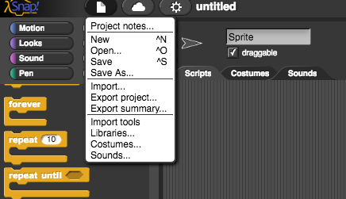

1. Write a script that will clear the screen, then draw a circle with different colors every time the green flag is clicked. You will need the following blocks, though they will not be used in this order):
   1. These are the blocks you need to draw a circle. However, you need to figure out how many times to repeat it!

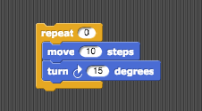

* 1. 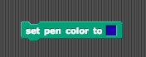
  2. Screen Shot 2017-05-27 at 3.28.09 PM.png
  3. Screen Shot 2017-05-27 at 3.14.29 PM.png
  4. Screen Shot 2017-05-27 at 3.14.32 PM.png
  5. Screen Shot 2017-05-27 at 3.20.10 PM.png

1. Test your script by clicking the green flag a few times. Make sure that each time, the circle disappears and you can watch the sprite draw the new one!
2. Write a second script so that when the space key is pressed, it will clear the screen, go to the center of the screen, then draw a circle with different colors forever, moving slightly each time. You will use some of the same blocks as the first script, and these new ones:
   1. Screen Shot 2017-05-27 at 3.40.01 PM.png
   2. 
   3. Screen Shot 2017-05-27 at 3.33.38 PM.png
3. Test your script by pressing the space key, and try clicking the green flag and then pressing the space key! When you’re done, save the project.
4. Create a new Project called “Assignment 1: Conditionals” in your Snap account.
5. Write a script so that when the green flag is pressed, the sprite will move if the space key is pressed. Have the sprite move and turn each time. You will need the following blocks, though not necessarily in this order:
   1. 
   2. 
   3. 
   4. 
   5. 
   6. 
   7. 
   8. 
6. Save the project